Puppet Assignments - Intellipact Module4

1. Assignment1
2. Setup a Master and 2 Worker nodes

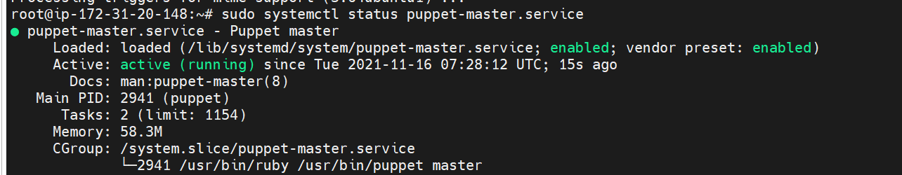

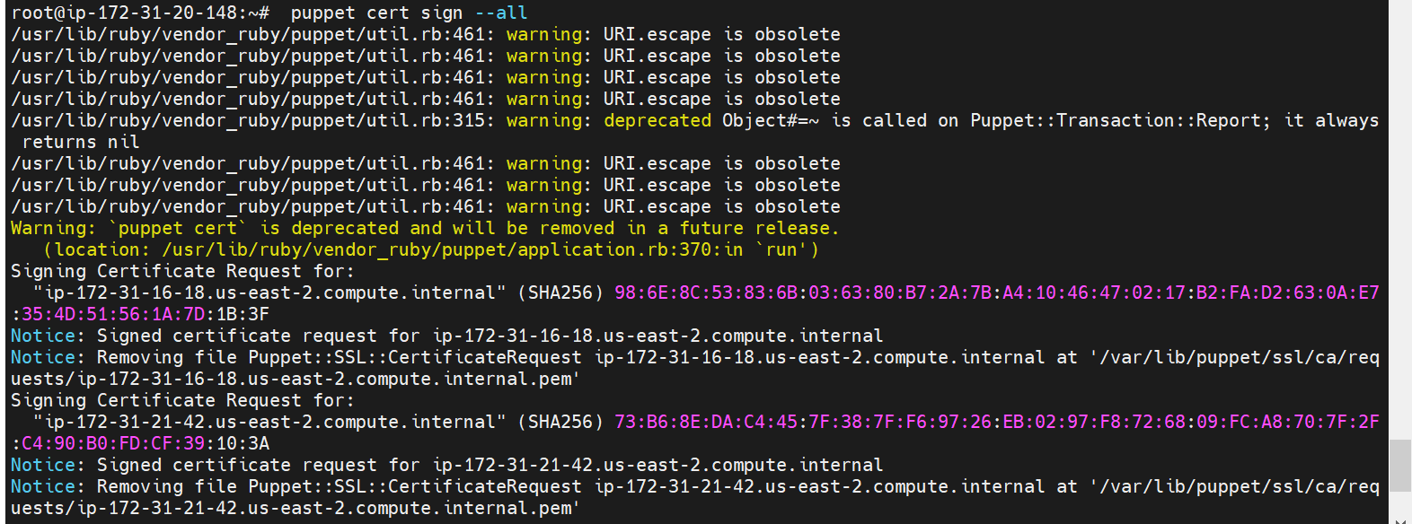

1. Install apache on workers using manifest file

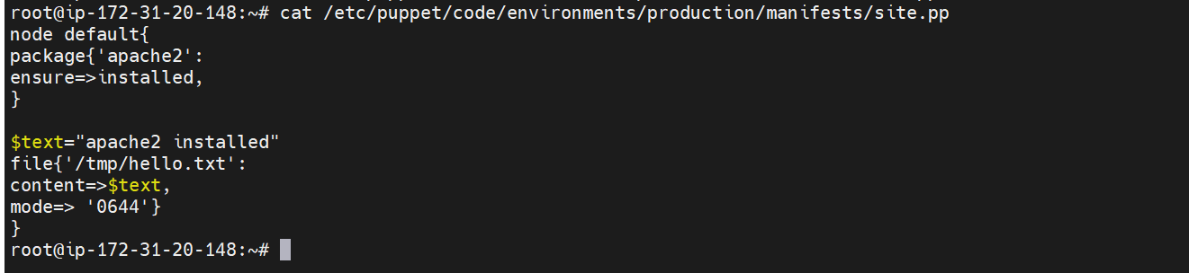

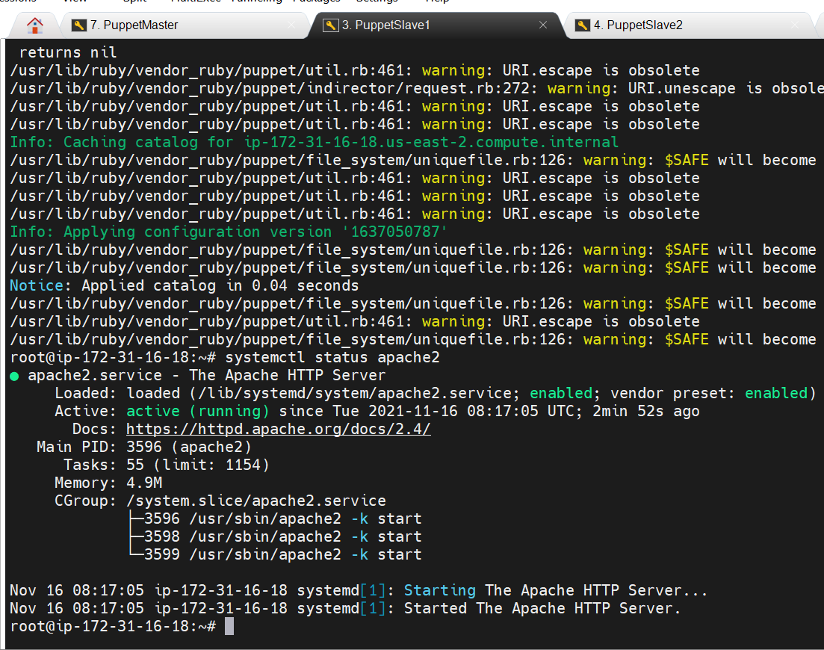

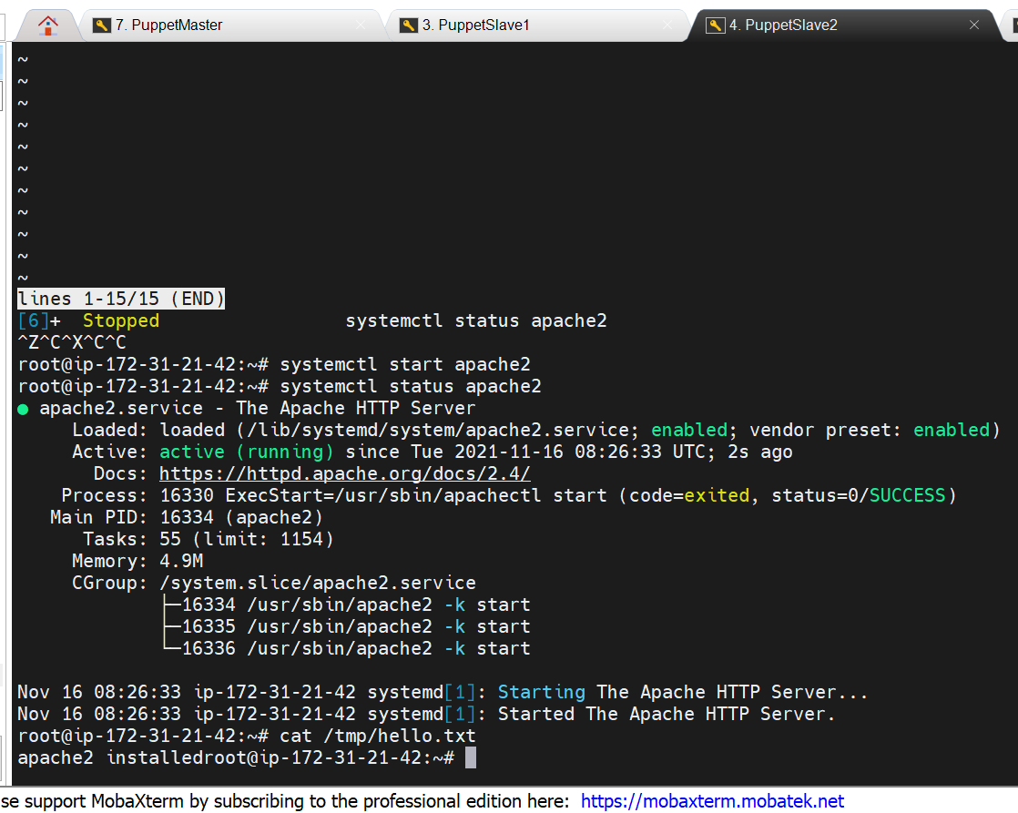

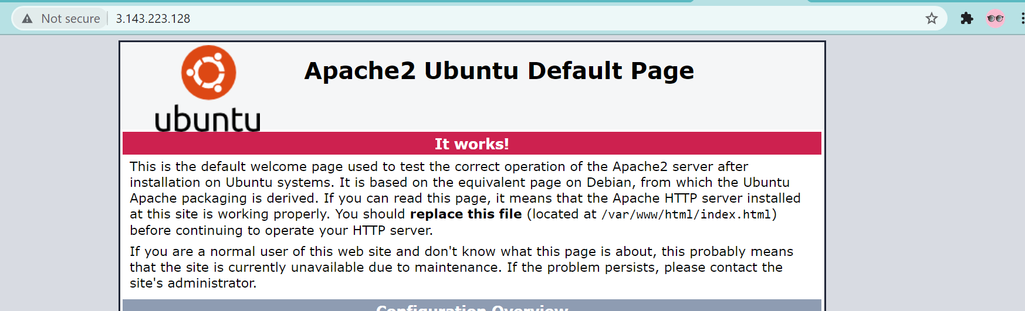

2. Assignment2

1. Add one more slave

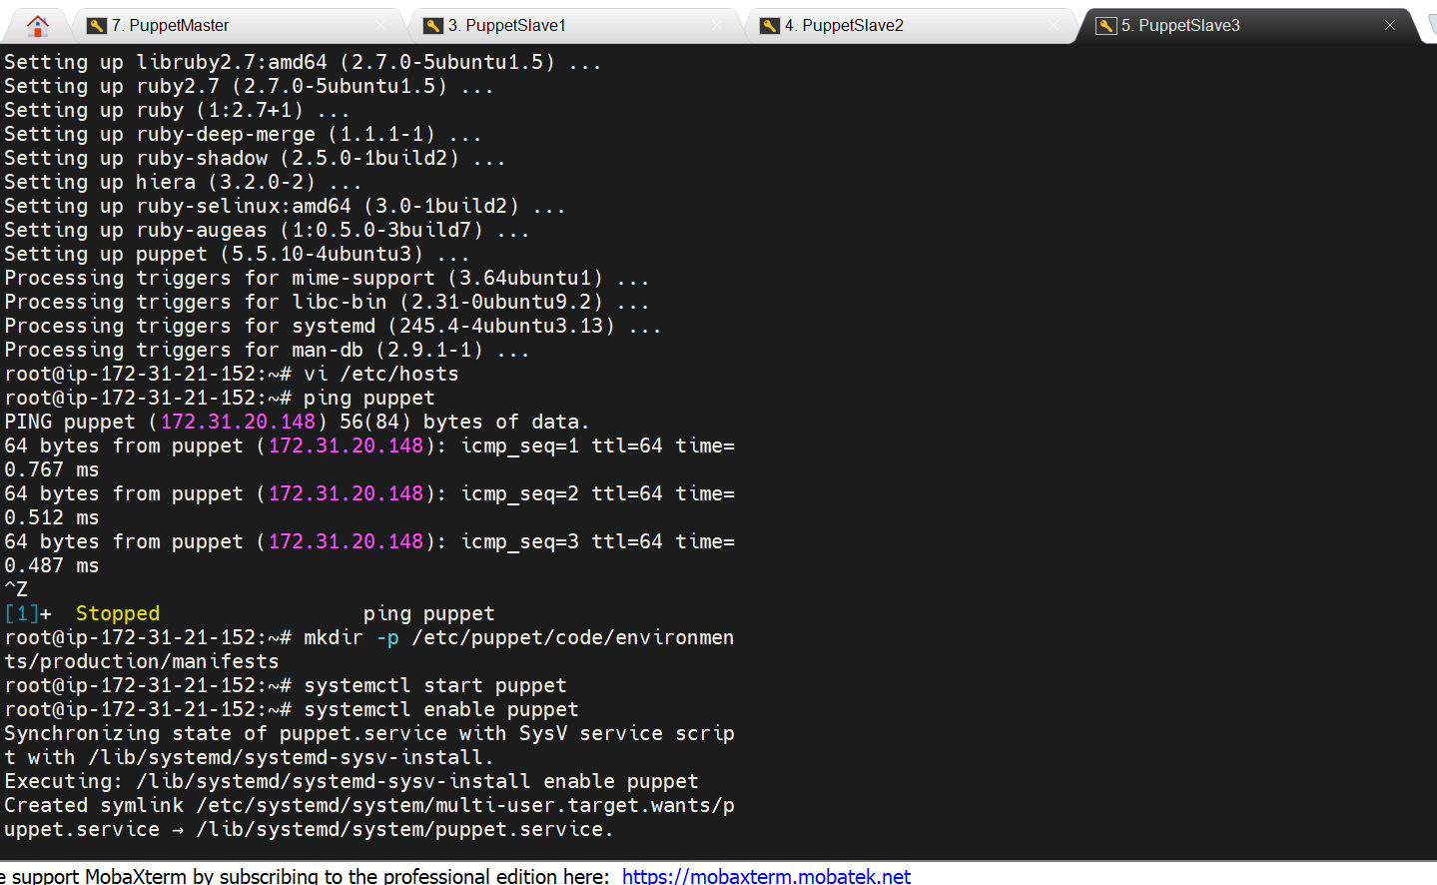

1. Add a condition, if apache is already installed then install ngnix



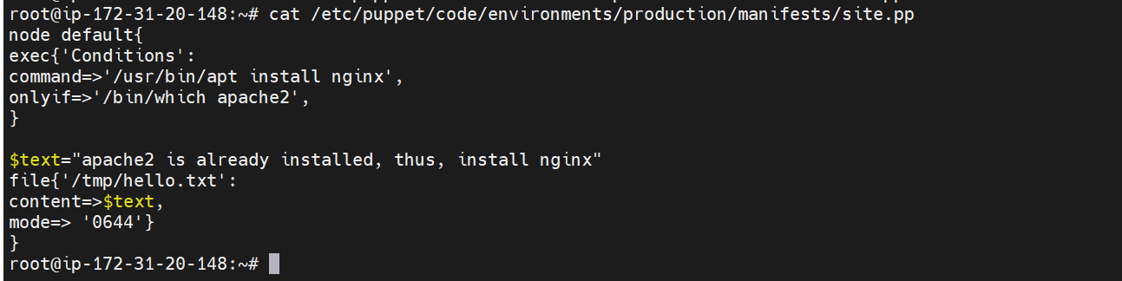

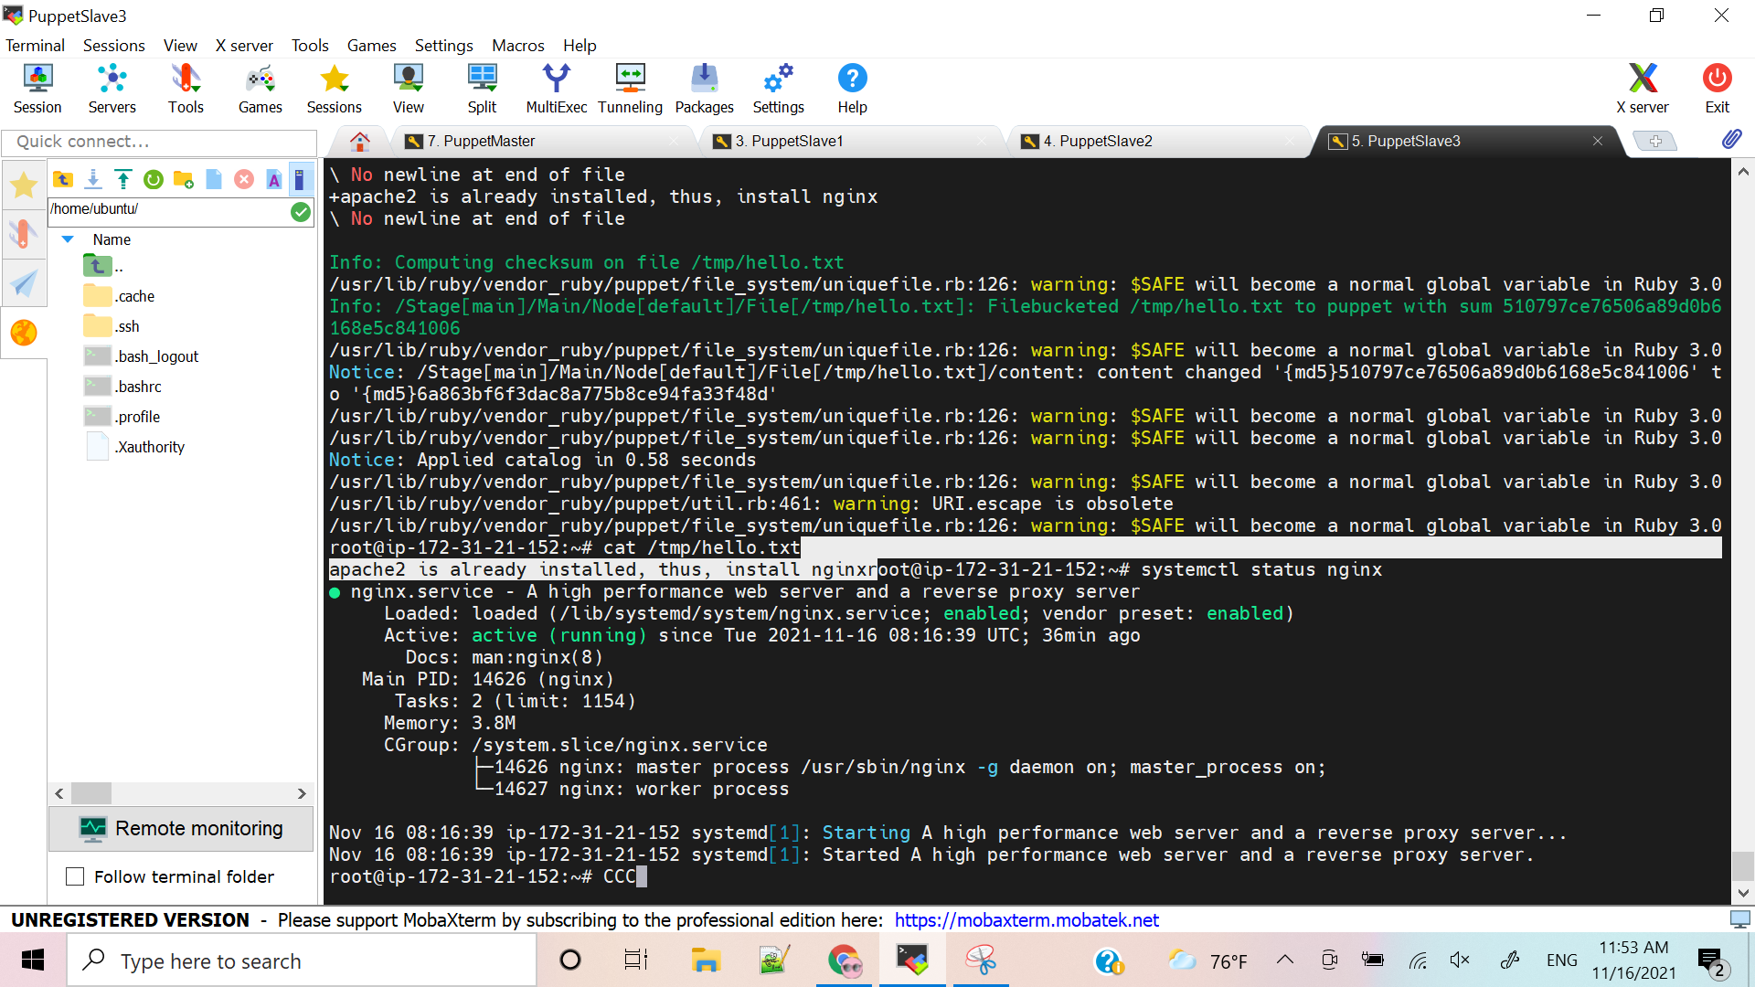

3. Assignment3

1. If apache is install then change index.html as “Apache is installed”
2. If nginxis install then change index.html as “nginx is installed”

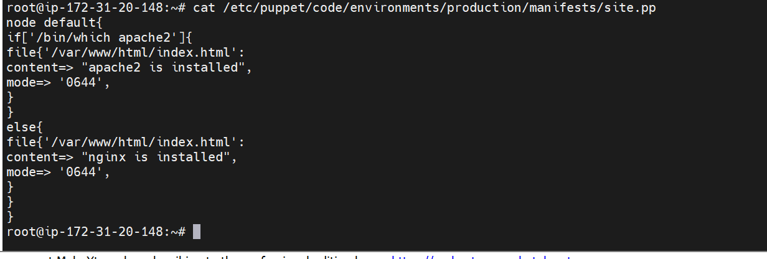

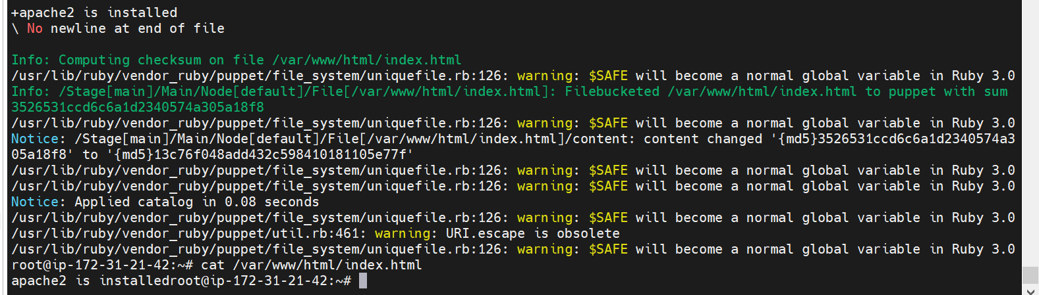

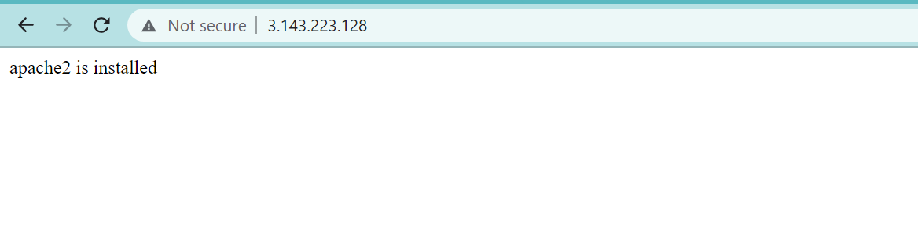

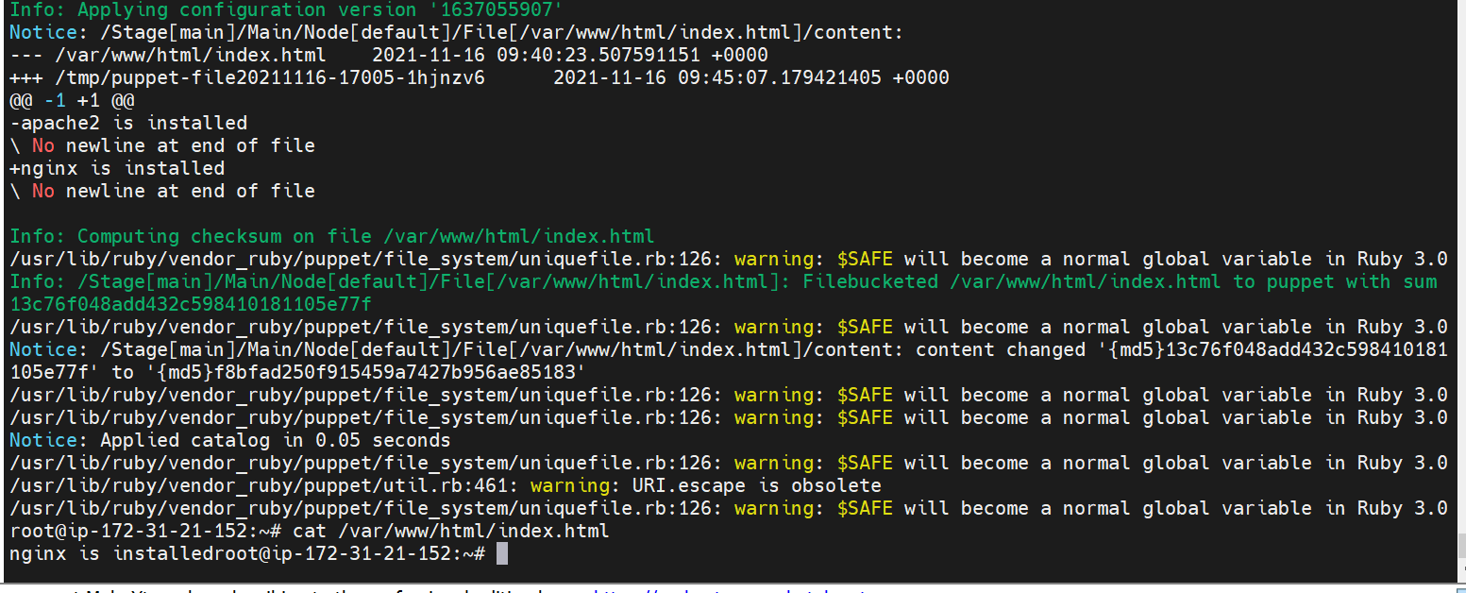

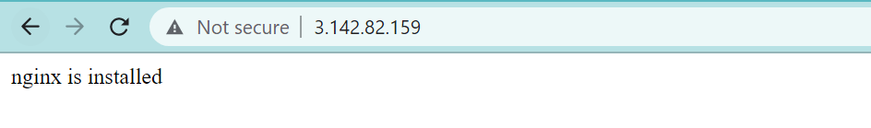

4. Assignment4

1. Ensure java and mysql are installed on nginx machine

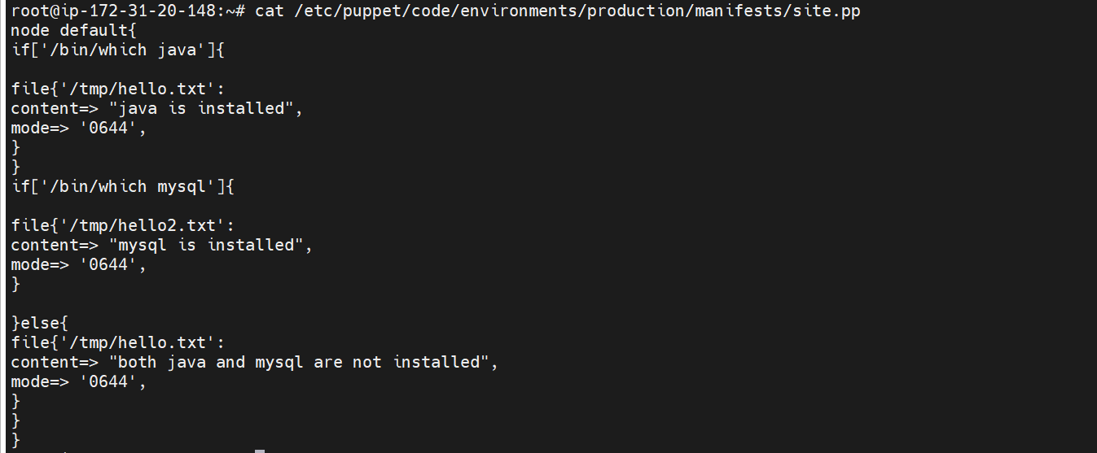

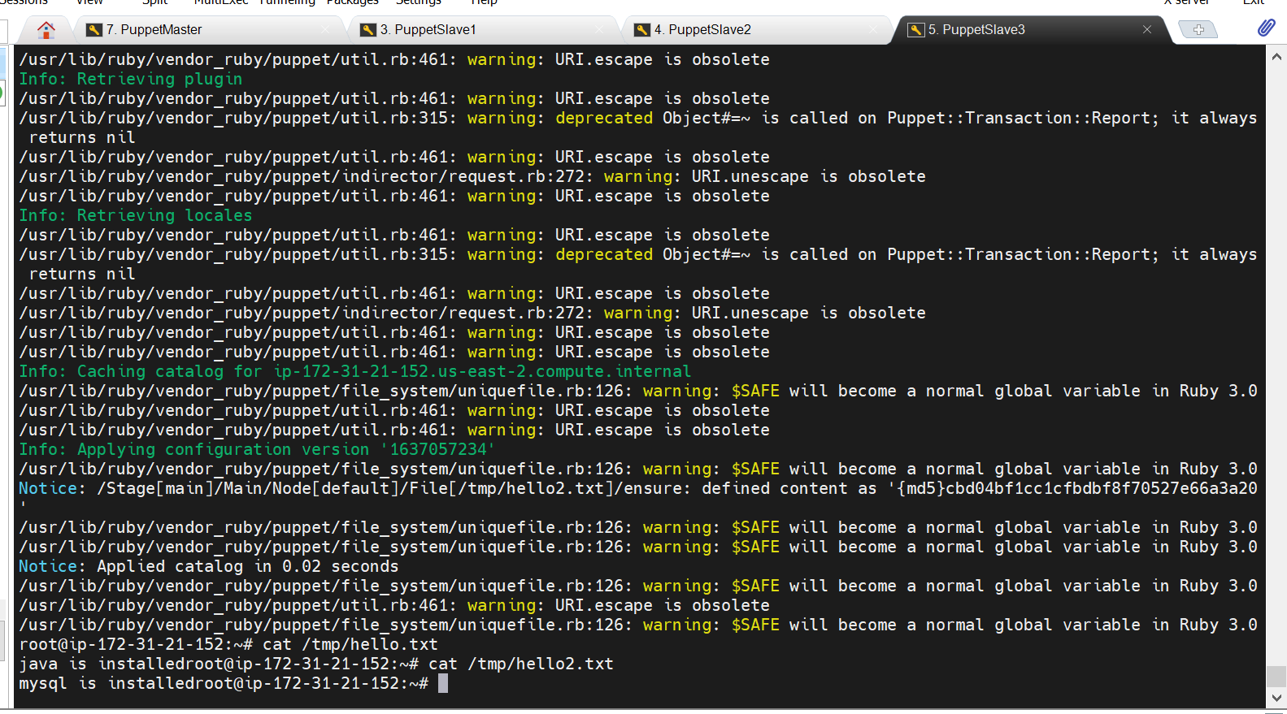

5. Assignment5

1. Assign hostname to slaves

